Raising money for Sussex Disability Charity
By ticking the box headed ‘Gift Aid’, I confirm that I am a UK Income or Capital Gains taxpayer. I have read this statement and want The Bevern Trust to reclaim tax on my sponsorship donation below, given on the date shown. I understand that should I pay less Income Tax / or Capital Gains tax in the current tax year than the amount of Gift Aid claimed on all of my donations, it is my responsibility to pay any difference.
I understand The Bevern Trust will reclaim 25p of tax on every £1 that
I have given. Please remember: You must provide your
full name, home address, postcode & ticked the Gift Aid
box for The Bevern Trust to claim tax back on your donation.
Sponsor’s First Names & Surname | Home Address (For Gift Aid) | Post Code | Donation Amount (£) | Date Paid | Gift Aid?
Edward Example | 1 Giving Street, Giving Town, Giving City | BN8 5FJ | £100 | 12.11.18 | Y

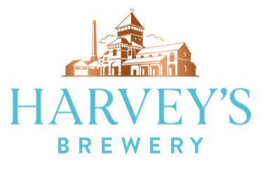
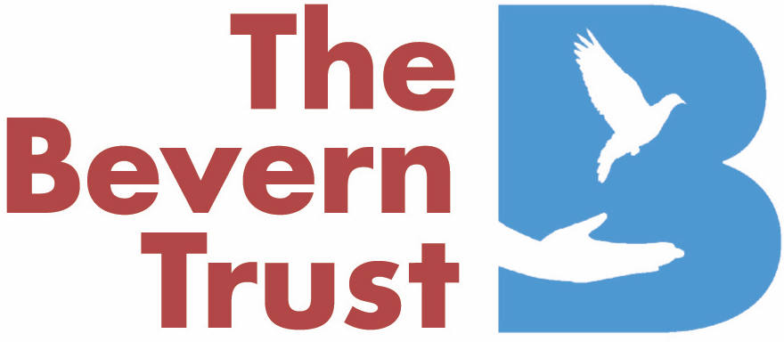
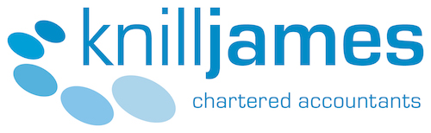
The Bevern Trust Lewes Santa Run: 7th December 2019
Kindly Supported by:
Please sponsor (your name) ……………………………….
Your Address ………………………………………………
Email …………………………………………………………….
Home Tel …………………………………………….……….
Mobile Tel ………………………………………………….….
The Bevern Trust, The Willows, Barcombe, Lewes BN8 5FJ www.beverntrust.org Registered Charity no.1103520
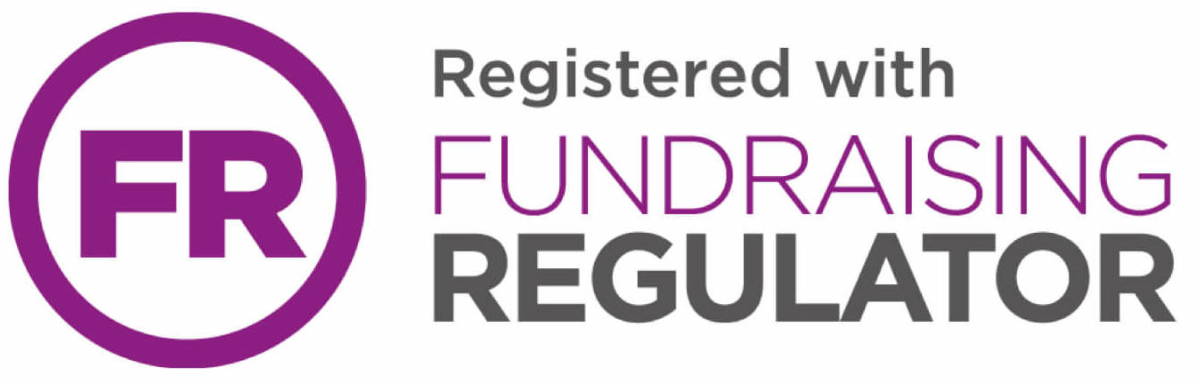
Please send sponsorship money and this form to: Santa Run, The Bevern Trust, The Barn, North Court, Lewes BN7 2AR. Make cheques payable to ‘The Bevern Trust’. For more information call 01273 021241 or email info@beverntrust.org
The Bevern Trust, The Willows, Barcombe, Lewes BN8 5FJ www.beverntrust.org Registered Charity no.1103520
Sponsor’s First Names & Surname | Home Address (For Gift Aid) | Post Code | Donation Amount (£) | Date Paid | Gift Aid?
Edward Example | 1 Giving Street, Giving Town, Giving City | BN8 5FJ | £100 | 12.11.18 | Y
TOTAL DONATIONS RECEIVED

